**Simulation :** NMOS

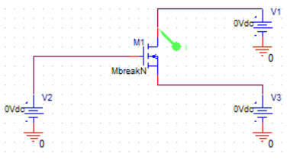

**Figure :** Circuit Diagram for NMOS.

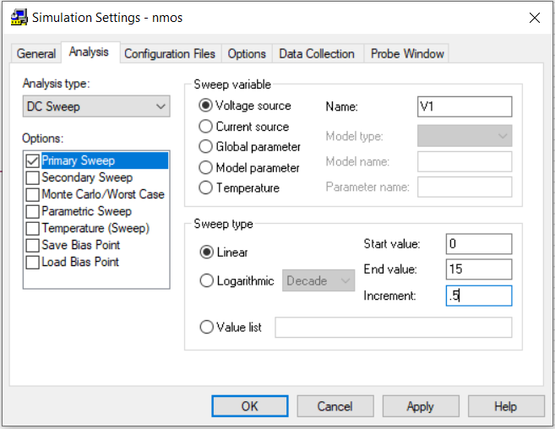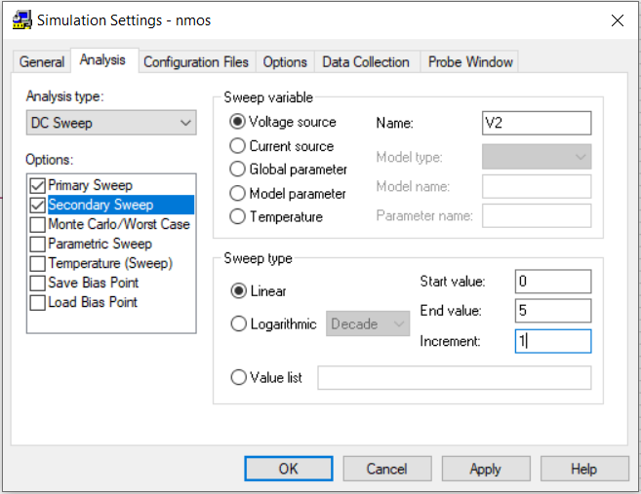

**Figure :** Input for NMOS.

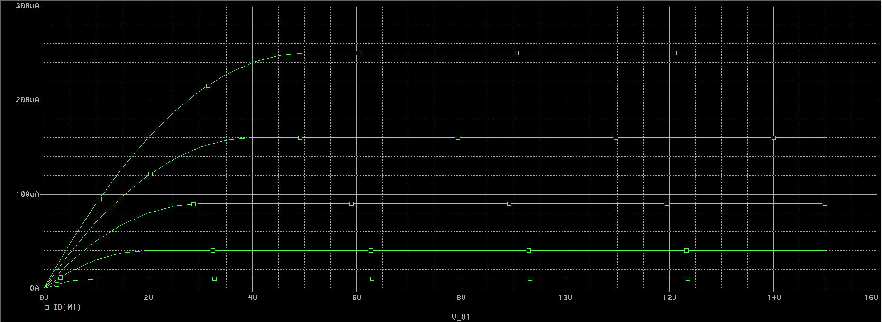

**Figure :** Resultant Curve for NMOS.

**Simulation :** PMOS

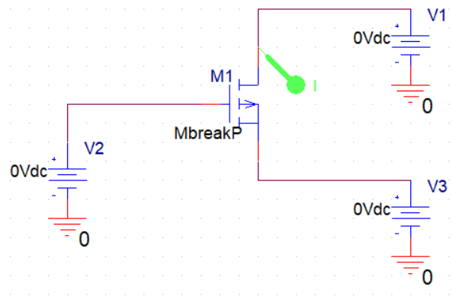

**Figure :** Circuit Diagram for PMOS.

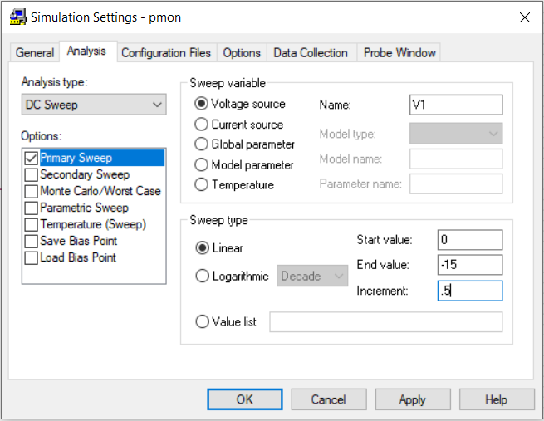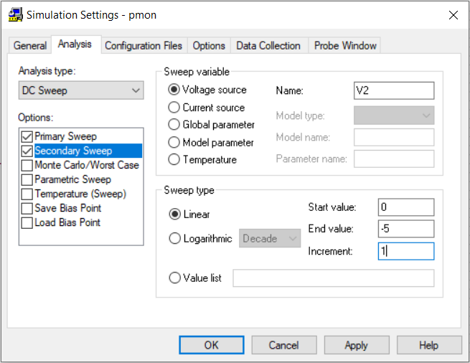

**Figure :** Input for PMOS.

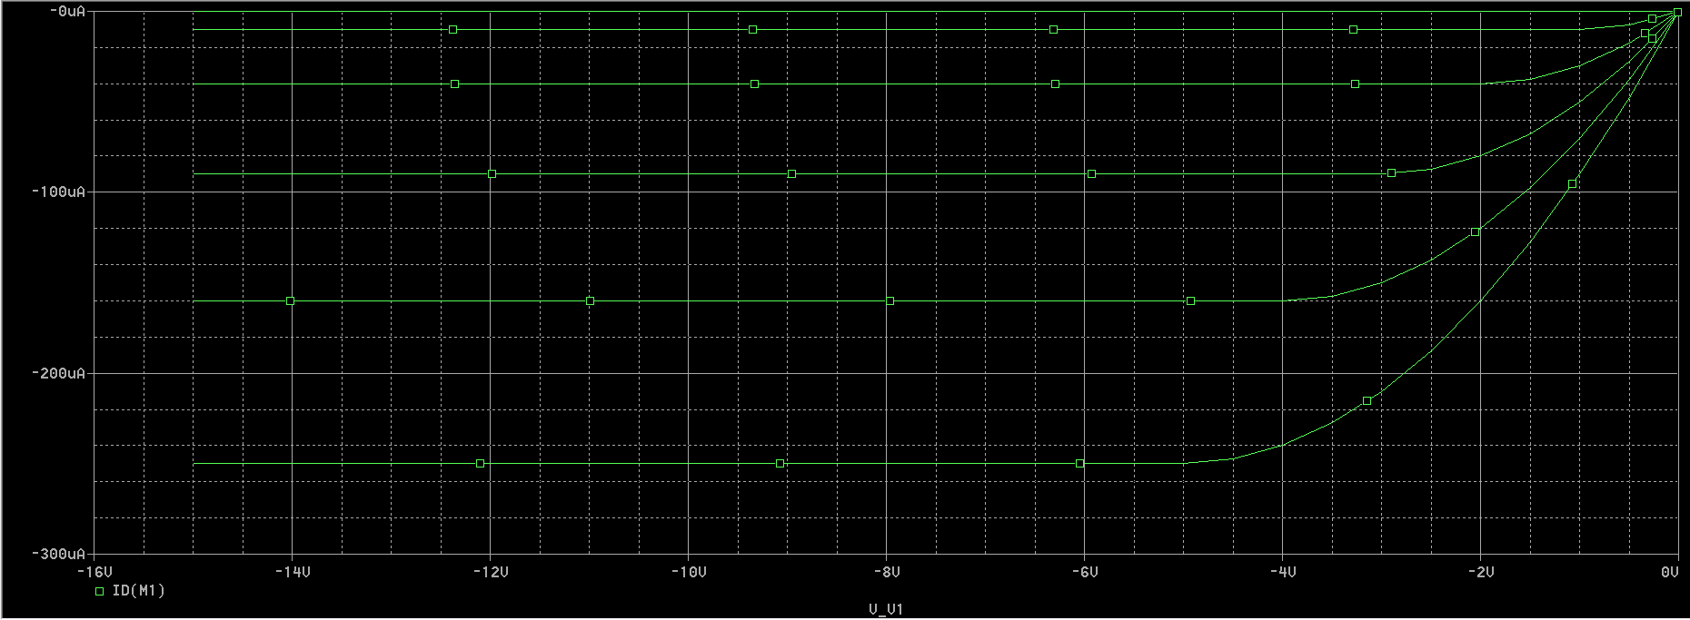

**Figure :** Resultant Curve for PMOS.